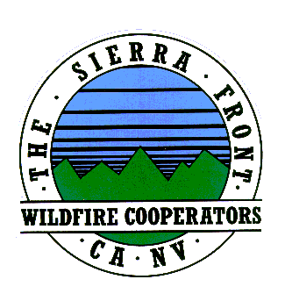
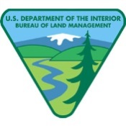
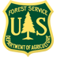
Announcement
Nate Rasner Sierra Front Type 3 Team
Mark Regan
Public Information Officer
Phone: 760-647-6472
Walkerfire2015@gmail.com
August 19, 2015 Announcement #3, 12:30 p.m.

Date Started: 8/14/2015  Cause: Human | Total Personnel: 484  Injuries/Illnesses to Date:0
Size: 3,715 acres | Structures Threatened: 235
Percent Contained: 35%  Resources: 4 helicopters, 0 seats 2 Air tankers Engines 34,Crews 10,Water Tenders 6, Dozers 4 | Structures Lost: 0  Estimated Containment:8/23/2015

If you Fly, We Can’t – Report of Drones near Walker Fire

Lee Vining, CA: Drones are becoming an increasingly popular recreational activity on forest land and throughout the country. However, drones flying near wildland fires pose a serious and immediate threat to the safety of aircraft crews involved in fire response.

Individuals and organizations that fly unmanned aircraft systems (UAS), more commonly referred to as drones, for hobby or recreational purposes may not operate them in areas of National Forest System lands that have Temporary Flight Restrictions in place, such as wildfires, without prior approval from the U.S. Forest Service.

The Federal Aviation Administration has regulatory authority over all airspace, including recreational use of airspace by model aircraft .Individuals and organizations that fly drones on National Forest System lands must follow FAA guidance – FAA guidance stipulates that UAS not interfere with manned aircraft, be flown within sight of the operator and be operated only for hobby or recreational purposes. The FAA also requires model aircraft operators flying UAS within five miles of an airport to notify the airport operator and air traffic control tower. For more information, watch the “Know Before You Fly” video https://www.youtube.com/watch?v=XF5Q9JvBhxM&feature=youtu.be(link is external) and visit the Know Before You Fly Website at http://www.knowbeforeyoufly.org/(link is external)

Please, for the safety of our firefighters and for an effective fire response, please keep drones away from the Walker Fire and near heliports.

###

