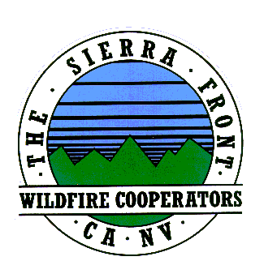
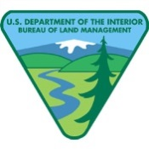
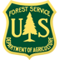
News Release
Nate Rasner Sierra Front Type 3 Team
Mark Regan
Public Information Officer
Phone: 760-647-6472
Walkerfire2015@gmail.com
August 20, 2015, Update #7 8:00 a.m.

Date Started: 8/14/2015  Cause: Human | Total Personnel: 477  Injuries/Illnesses to Date: 0
Size: 3,715 acres | Structures Threatened: 235
Percent Contained: 45%  Resources: 3 Helicopters, 0 Seats, 0 Air Tankers  34, Engines Crews, 6 Water Tenders, 2 Dozers | Structures Lost: 0  Estimated Containment: 8/23/2015
Significant progress continues with containment lines on Walker Fire
Lee Vining, CA: Burning approximately two miles southwest of Lee Vining the Walker Fire remains at
3,715 acres. This is a human-caused fire that is still under investigation.

Crews will continue to improve containment lines as well as mop up, which includes extinguishing
hot spots to ensure that the fire does not re-ignite. Mitigation efforts also continue on the 65-acre spot fire.

Tioga Pass (Highway120) is open without an escort. However, there will be no stopping along the eastern
four miles of the road. This will be strictly enforced. The fire remains active to the south of the road and this
is essential for firefighter and public safety.

The fire is burning in mixed conifer, mahogany, and brush. Critical sage grouse habitat is also threatened. Visitors and residents should expect to see smoke from the June Lake and Lee Vining areas and along Highway 395.

For the safety of our firefighters, effective air operations and continued containment efforts, please keep drones away from the Walker Fire and near heliports.
Closures and Evacuations:
- Walker Lake “Fishing Camp” has been evacuated.
- A CodeRed Emergency Alert notice has been issued for Lee Vining and everything north of Double Eagle in June Lake (including Silver Lake and Grant Lake areas) for potential evacuations.
- Campgrounds in the Lower Lee Vining Canyon have been evacuated and are closed, including Lower Lee Vining, Moraine, Boulder, Aspen Grove, and Big Bend Campgrounds.
- The Walker Lake Road (1N17), the Parker Lake Rd. (1S25), the Upper Horse Meadows Rd. (1N16), and the Gibbs Road (1N18) are closed for fire operations and public safety. All of these roads are accessed via the northern end of the June Lake Loop. All spur roads off of these roads are also closed. The trail to Mono Pass (trailhead is at Walker Lake) is closed.
Approximately 477 firefighters are on scene as well as numerous aircraft, dozers, and engines. Resources from Mono County, local fire departments, Cal Fire, neighboring forests, BLM Bishop Field Office, and the Mono County Sheriff’s Office are assigned. For more information on the Walker Fire you can go to the following sites: Inciweb: http://inciweb.nwcg.gov/incident/4515/
Facebook: https://www.facebook.com/inyonfhttps://www.facebook.com/pages/Mono-County-Sheriffs-Office/597961140216123

####

