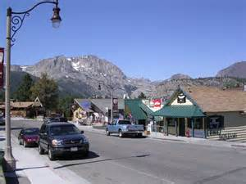

*Wednesday, July 30, 2014*

**Opening Workshop:**

***Community Values and Priorities***

Business Owner Focus Group

5-6 pm @ June Lake Community Center

6-7:30pm Walking Assessment of Project Area

*Friday, August 1, 2014*

**Closing Presentation of Ideas and Plan**

6-7:30 pm @ June Lake Community Center

Light Food and Refreshments Provided!

June Lake Main Street Project

**Mono County, in collaboration with community partners, public agencies, and a federal scenic**

**byway grant invite you to help plan your main street**

**Design Fair Workshops**

**For more information:**

**Courtney Weiche (760) 924-1803** [**cweiche@mono.ca.gov**](mailto:cweiche@mono.ca.gov)

**Gerry LeFrancois (760) 924-1810** [**glefrancois@mono.ca.gov**](mailto:glefrancois@mono.ca.gov)

A team of design experts will translate your vision into a plan to make June Lake a more inviting place to walk, shop, gather and do business.

*Want to help:*

* *Enhance the sense of community vitality on Main Street?*
* *Foster a vibrant economy?*
* *Improve safety for walkers, cyclists and drivers?*
* *Support historic and community character?*

*Then join us for a conversation about the future of Main Street and how to better meet community needs!*

