NOTICE OF PUBLIC MEETING AND AGENDA
MONO COUNTY COMMUNITY CORRECTION PARTNERSHIP
EXECUTIVE COMMITTEE

Meeting Location – Mono County Superior Court, 1st floor Hearing Room, 100 Thompson Way, Mammoth Lakes, CA. 93546
Committee Members may participate from a teleconference location. Note: Members of the public may attend the open-session portion of the meeting or may attend from a teleconference location, and may address the board during any one of the opportunities provided on the agenda under Opportunity for the Public to Address the Board. If a member of the public wishes to attend by teleconference, it must be set up prior to the meeting date by contacting Karin Humiston at 760-932-5570.
In compliance with the Americans with Disabilities Act if you need special assistance to participate in this meeting, please contact Karin Humiston, at 760-932-5570. Notification of 48 hours prior to the meeting will enable the County to make reasonable arrangements to ensure accessibility to this meeting.
Full agenda packets are available for the public to review in the Probation Department, located in Bridgeport. ON THE WEB: You can view the upcoming agenda at http;//monocounty.ca.gov. UNLESS OTHERWISE SPECIFIED BY TIME, ITEMS SCHEDULED FOR EITHER THE MORNING OR AFTERNOON SESSIONS WILL BE HEARD ACCORDING TO AVAILABLE TIME AND PRESENCE OF INTERESTED PERSONS. PUBLIC MAY COMMENT ON AGENDA ITEMS AT THE TIME THE ITEM IS HEARD.

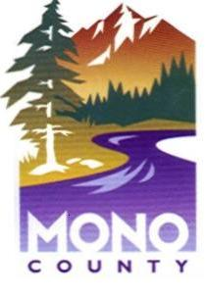

SPECIAL MEETING
AUGUST 2, 2017 – 11:00 A.M.

