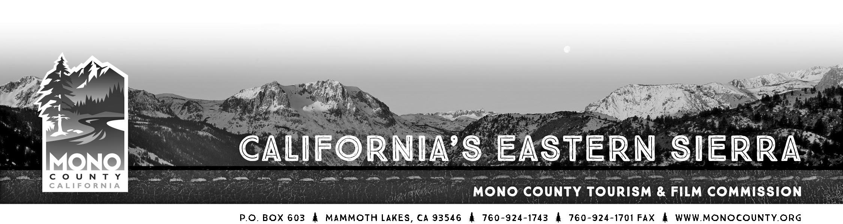

MINUTES

MEETING of Tuesday, August 25th, 2015 - 10:00am
June Lake Community Center
90 W. Granite Ave. June Lake, CA 93529

Attending: Andrew Jones, Jimmy Little, Michael Vanderhurst, Steve Morrison
Absent: Chris Long, Jennifer Roeser
Staff: Alicia Vennos, Jeff Simpson, Liz Grans
Other: John Poimiroo (Californiafallcolor.com), Jenny Coupelda (ESIA), Christie Osborne (Mammoth Lakes Tourism), David & Denise Naaden (Reverse Creek Lodge), Terry & Dawn Schultz

- Call to Order. Meeting was called to order at 10:06am by Commissioner Little.

- Introductions and announcements. Introductions were made.
- Opportunity for the Public to Address the Commission on items of interest of the public which are within the subject matter jurisdiction of the Commission. (Speakers may be limited in speaking time depending upon the press of business and number of persons wishing to address the Commission.)

- Presentation: Profiting from Autumn by John Poimiroo, Editor and Publisher of CaliforniaFallColor.com. Excellent presentation by Mr. Poimiroo on fall color, the basics of why leaves change color, how to take pictures and report changes, creating a cohesive communications/marketing/welcome message to attract and inform visitors and capitalize on this market during shoulder season.

- Focus Group Discussion: Preparing for Mono County Tourism’s New Website. Excellent feedback from meeting attendees on what they would like to see (or not see) on the new MonoCounty.org tourism website. Overall themes were simple, clean, mobile-friendly but not necessarily a mobile-specific site, perhaps a new URL, creating a better link on the monocounty.ca.gov site to direct people to the tourism site, keeping content in easily translatable phrases, etc.
- Monthly Financial/Budget Report. The Mono County Board of Supervisors passed the budget. Funded: $20,000 in the Community Event Marketing Fund, $8,000 to Friends of the Inyo trail maintenance, $10,000 for the ESVC and State Fair, $5,000 for Film Commission marketing, $6,000 for historical societies and museums, $50,000 for air service.

- Commissioner Reports. Commissioner Morrison reported filming was quiet, not necessarily due to smoke. VW, Toyata both filmed recently. Inquiry for a 7-day reality TV show.

- Commissioner Elections for Chair and Vice-chair. ACTION: Commissioners to nominate and vote for the positions of Mono County Economic Development, Tourism & Film Commission chairperson and vice-chairperson for a one-year term.
MOTION MADE BY COMMISSIONER VANDERHURST AND SECONDED BY COMMISSIONER MORRISON TO REAPPOINT COMMISSIONER LITTLE AS CHAIR AND COMMISSIONER JONES AS VICE CHAIR. APPROVED 4-0, NO ABSTENTIONS.
- Economic Development Report. Exploring new tradeshow opportunities, still working on plans for the State of County and booking a speaker who can talk about the importance of connectivity.

- Fisheries Commission Report.
- Film Commission Update.
- Project Status Update:
a. Collateral
b. Public Relations
c. Advertising/Social Media/E-Newsletter
d. Website

15. Call for Agenda items for next regular meeting.
16. Adjourn the meeting and reconvene in regular session on September 22, 2015 at 10:00am at the Lee Vining Community Center (296 Mattly Ave., Lee Vining, CA 93541).

Note: Start times are tentative. Although the Commission strives to follow the agenda as scheduled, it reserves the right to take any agenda item, in any order, at any time after the meeting starts. The only way to ensure you are present for a particular agenda item is to attend the meeting from the time is begins until that agenda item is addressed.

