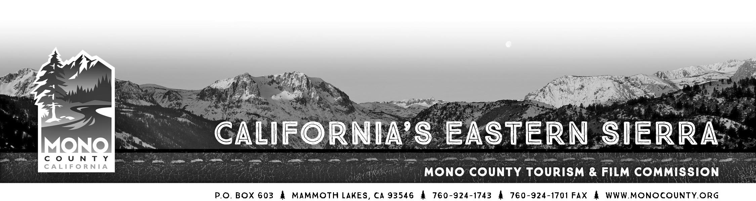

MINUTES

MEETING of Tuesday, September 22, 2015 - 10:00am
Lee Vining Community Center
296 Mattly Ave, Lee Vining, CA 93541

Attending: Andrew Jones, Michael Vanderhurst, Steve Morrison, Chris Long
Absent: Jennifer Roeser, Jimmy Little
Staff: Alicia Vennos, Liz Grans
Other: Geoff McQuilkin (Mono Lake Committee)

- Call to Order. The meeting was called to order at 10:13am by Commissioner Jones.

- Introductions and announcements.

- Opportunity for the Public to Address the Commission: Mr. McQuilkin introduced himself to the Commission, gave a brief overview of the Mono Lake Committee and provided MLC handouts with visitor information printed in different languages.
Phone call with Bonnie Tamblyn, Nancy Willard, and Mike, representatives from the June Lake Loop Performing Arts Association: JLLOOPAA called in to explain to the Commission why the 2015 event had been cancelled. A variety of challenges were discussed. They will make a presentation at the October meeting regarding a proposed plan to hold the event in 2016.

- Approval of the Minutes of the June 23, 2015 meeting. MOTION MADE BY VANDERHURST, SECONDED BY MORRISON, TO APPROVE THE MINUTES OF THE JUNE 23, 2015 MEETING. APPROVED 4-0, NO ABSTENTIONS.

- Approval of the Minutes of the August 25, 2015 meeting. MOTION MADE BY VANDERHURST, SECONDED BY MORRISON, TO APPROVE THE MINUTES OF THE AUGUST 25, 2015 MEETING. APPROVED 4-0, NO ABSTENTIONS.

- Monthly Financial/Budget Report. Ms. Vennos updated the Commission that Mono County is now working with a new finance software system, and will be able to provide much better and customized reporting. She will have an updated report at the next meeting.

- Commissioner Reports.
Commissioner Vanderhurst: Working with Mono County staff on the upcoming German travel trade fam trip on 9/24 and Visit CA press trip on 10/1. Lara with Visit Mammoth is working on the recently secured SATW fam trip that will be in June 2016.
Commissioner Morrison: Quiet, no filming or real leads right now. Subaru is looking to film end of November if there is snow. And HBO series was looking for a cabin for a TV series. Attending the COLA awards ceremony with Ms. Vennos in October.
Commissioner Long: The Birding and Hiking events were a great success, really good feedback from participants. Ran TV ads on Fox in Sacramento and Reno which worked well. The event coincided with the opening of deer hunting, but nonetheless they were able to hike and spot several species of birds, many on migration. The birding events seemed more popular than the hiking. The guides and leaders were all excellent. Reps from the Audubon Society also attended the event. Foundation has been laid for a very successful annual event.
Commissioner Jones: First-ever June Lake Jam Fest event was a success and drew over 120 people. The June Lake Autumn Beer Fest is next, and a great fall color season. The fishing contest hosted by Shelia Thomson had 50 people signed up.

- Economic Development Report & Strategy Discussion.
Staff met with Nate Greenberg regarding creation of an “office for a day” space; met with TOML staff regarding the creation of a “Welcome Packet” for new businesses/those interested in starting a business; toured the Sierra Business Park with Shields Richardson to view open units and potentially help match new businesses; had a phone meeting with Great Basin Bakery, who is opening a location in Mammoth Lakes soon, and connected the owner with Kelly Bearden of the SBDC Bakersfield; and lastly, met with MMSA sales manager to help MMSA with film location promotion.
- Fisheries Commission Report.
The Mono County BOS approved the Fisheries Commission’s request to use $700 from the Fish & Game Fine Fund for the Mammoth Creek Clean-Up event on Saturday, October 11, 2015.

- Film Commission Update. Ms. Vennos indicated that her report echoed Mr. Morrison’s in his Commissioner update.

- Historical Society & Museums Fund – Discuss 2016 program parameters.
Staff will create the application for review at the next meeting, loosely based on the CEMF application, allowing the historical societies/museums to apply for grant funds for a wide variety of needs, and that the grants can be awarded at the staff’s discretion with a final summary given to the Commission.

- Community Event Marketing Fund – Discuss 2016 program parameters.
Staff will create the application for review at the next meeting, where a few revision and additions, based on the 2015 CEMF cycle. Revisions will include information about reimbursements being issued only after the event has happened, and perhaps an event cancellation policy. Aiming for a similar grant cycle time frame as 2015.

- Project Status Update:
a. Collateral. No update provided.
b. Public Relations: East River PR represented Mono County at the Visit California San Francisco media event in September. Huge 12-page feature in Sunset Magazine, a road trip up Hwy 395. Fall color updates in full swing.
c. Advertising/Social Media/E-Newsletter: first Economic Development ad ran on the back of the Scenic 395 magazine. Tourism ads on the inside cover of the WON Fall Fishing guide, the Eastern Sierra Fishing Guide, and Sierra Fisherman (with full-page photos from Mono County Tourism featured in editorial). An ad is being prepared for the Visit California official Visitor Guide.
d. Website: Mr. Simpson reported that we are in the development process with Simpleview. Wire-frame stage is next.

12. Call for agenda items for next regular meeting.

13. Adjourn the meeting and reconvene in regular session on October 27, 2015 at 10:00am at the Bridgeport Health Department Annex (199 Twin Lakes Rd., Bridgeport, CA 93517).

Note: Start times are tentative. Although the Commission strives to follow the agenda as scheduled, it reserves the right to take any agenda item, in any order, at any time after the meeting starts. The only way to ensure you are present for a particular agenda item is to attend the meeting from the time is begins until that agenda item is addressed.

