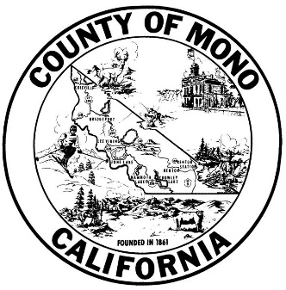
SPECIAL DISTRICT VACANCY NOTICE
Member, Board of Trustees
MAMMOTH LAKES MOSQUITO ABATEMENT DISTRICT

Current vacancies:
Five (5) expired terms

There are currently five (5) vacancies for expired terms on the MAMMOTH LAKES MOSQUITO ABATEMENT DISTRICT to be filled by appointment of the Mono County Board of Supervisors. These five vacancies are for members of the Board of Trustees, which are appointed at-large for either two or four year terms at the Board of Supervisors’ discretion, and will serve without compensation.

Qualifications for appointment:

- Voter in Mono County and resident of portion of Mono County within District;
- A member of town council may be appointed if meets other qualifications;
- Experience, training, and education in fields that will assist in the governance of the District; and
- Represents interests of the public as a whole.
(Health & Safety Code Section 2022.)

To apply:

Individuals interested in serving on the Mammoth Lakes Mosquito Abatement District Board of Trustees should submit an application to the Clerk of the Mono County Board of Supervisors, P.O. Box 715, Bridgeport, CA 93517. You may obtain an application by contacting the Clerk’s office at (760) 932-5534 or by visiting our web page.

Posted: 5/22/17 at Mono County Clerk’s Office, Bridgeport Library, Mammoth Library, and www.monocounty.org/bos; also sent to newspaper for publication on 5/22/17.

cc: Mammoth Lakes Mosquito Abatement District

